**Lear Corporation**

**APODACA e-System**

**May 15th**

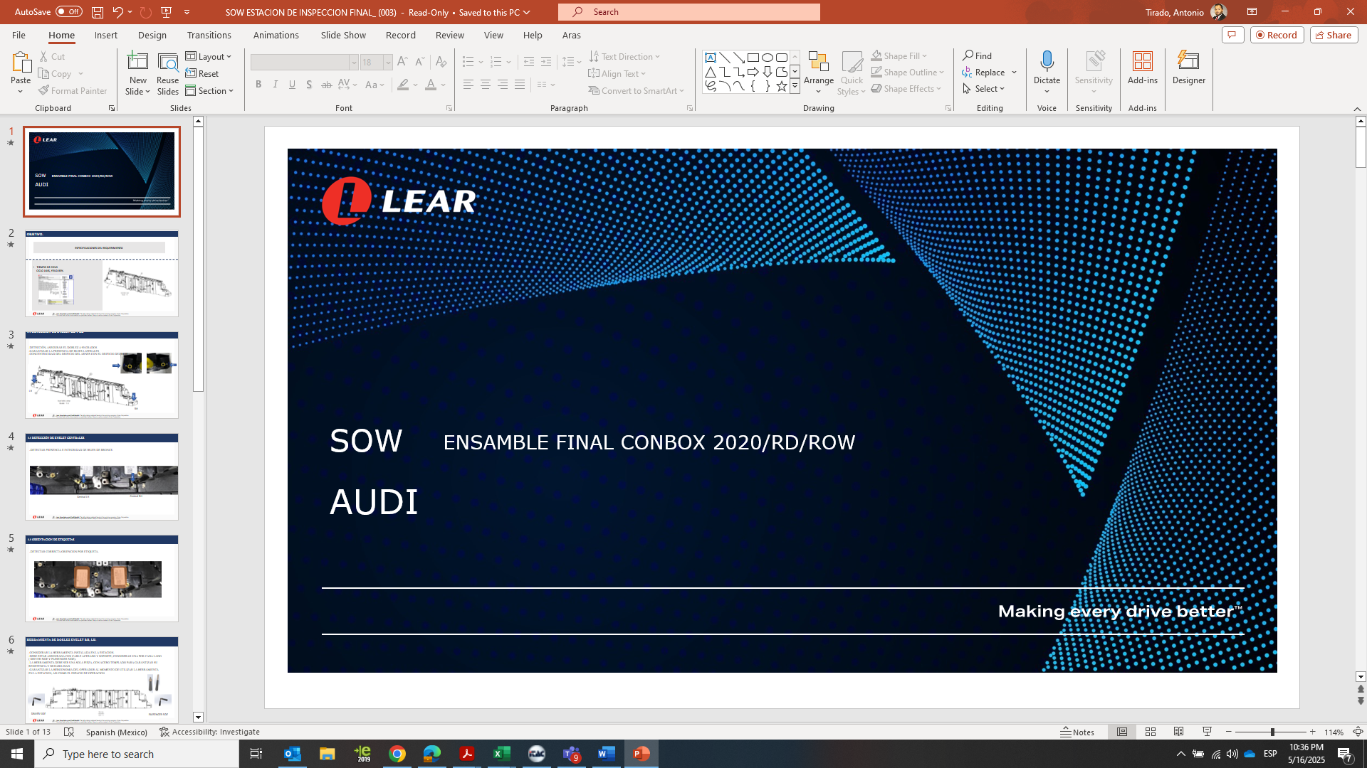

**Monterrey Nuevo Leon**

**Upgrade concept to C-box Assembly line**

Final Customer AUDI

**General Statements**:

Based on a volume increase made by our client AUDI, on the Conbox 2020, Conbox Redisign (RD), Conbox Rest of the World (ROW) Platforms, the C-Box Low final assembly line requires an upgrade for the homologation between Conbox 2020 and C-Box Low.

**Conbox Takt time: 35 seg/pcs**

Line: G17 -21-LEA

Year manufacturer: October 7th 2017



**Changes for current Line.**

The supplier (IPTE) must consider the conceptual distribution of the principal’s components as the document shows bellow.

*CBOX CURRENT LINE -*

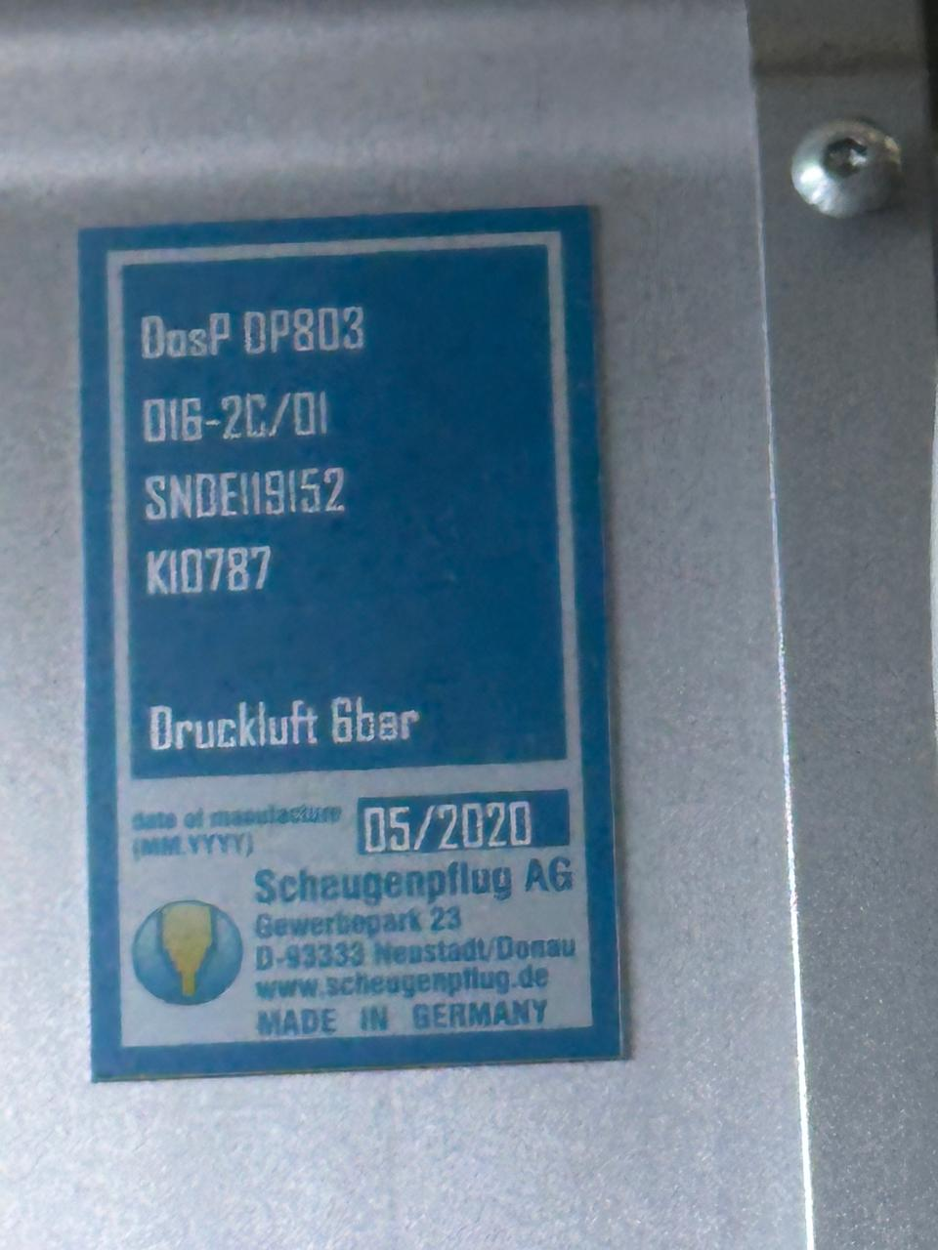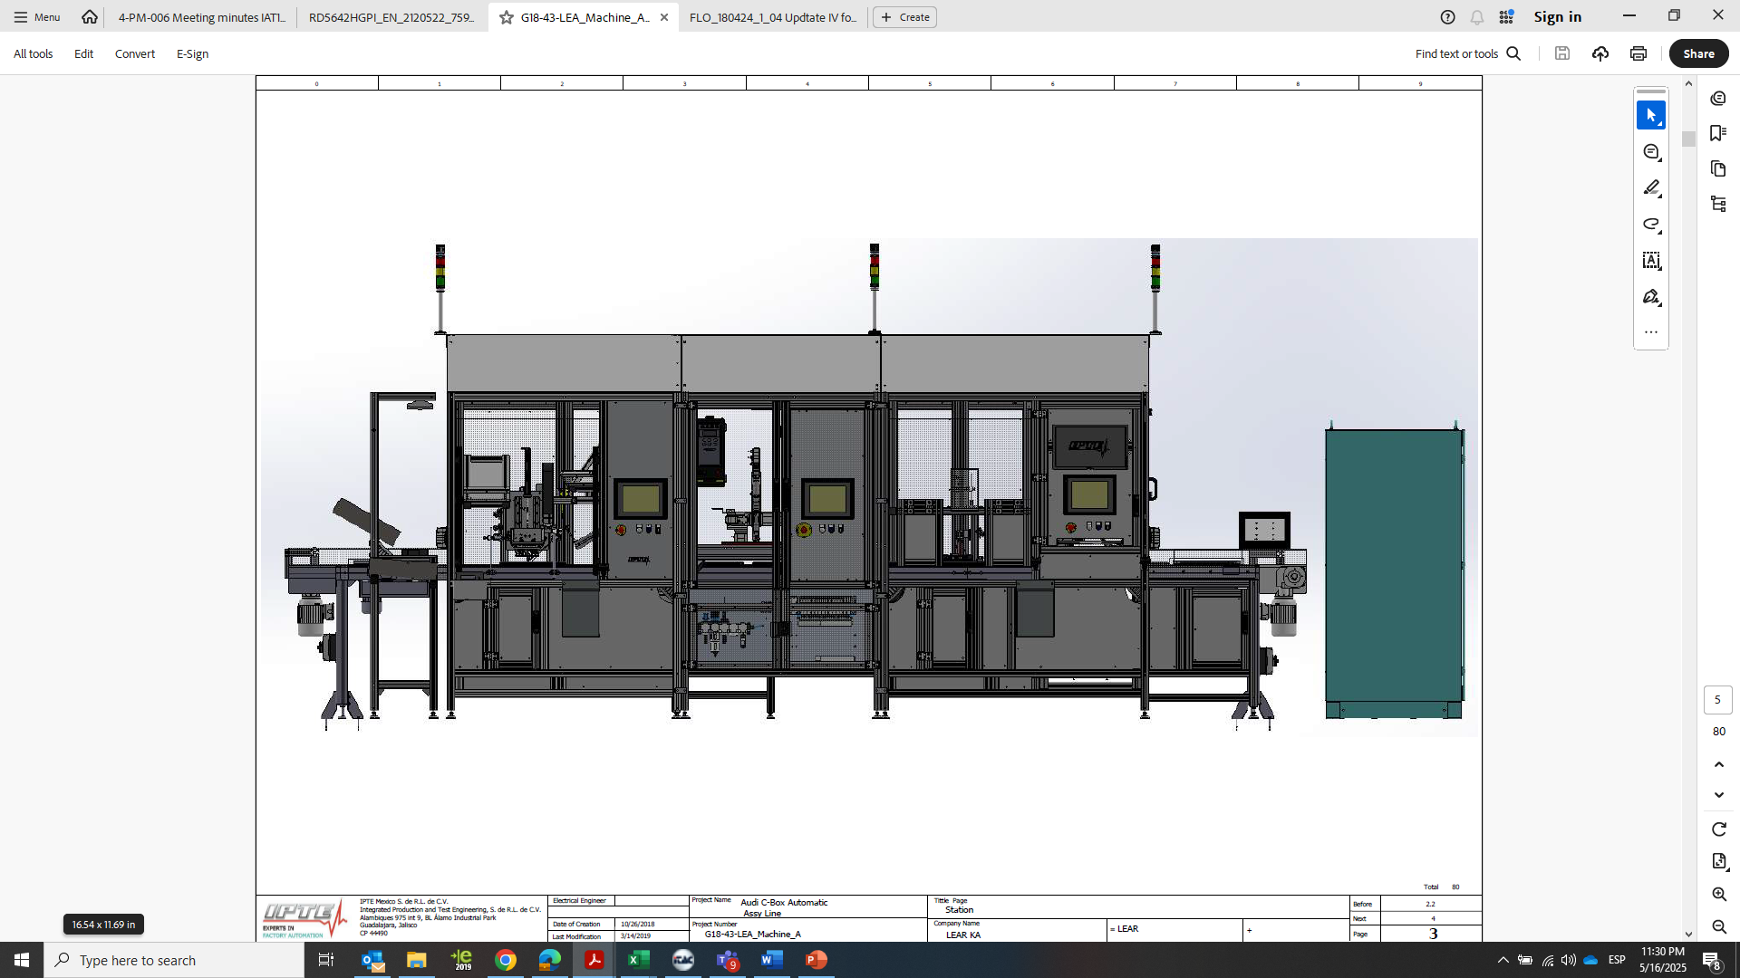

Transfer And Loading Station

*CHANGES –*

*Cycle time: 35 seg.*

Adding Gap Filler System for Scheungenpflug Atlas Copco

* Volumetric Head
  + DosP DP803
  + 016-2C/01
  + 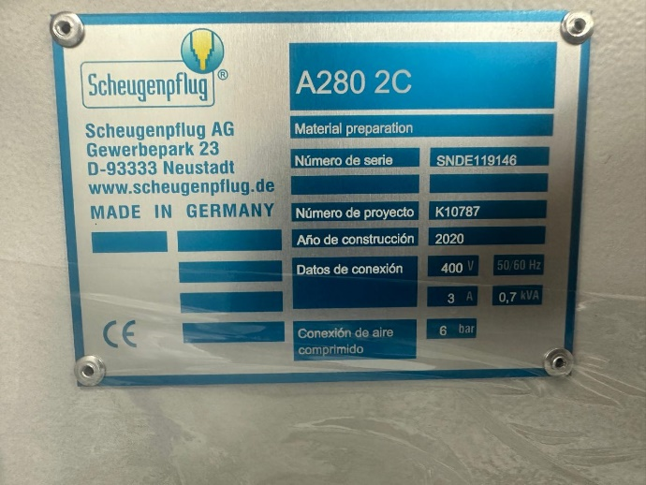SNDE119152
  + K10787
* Pump & container system
  + Model: A280 2C
  + Número de Proyecto K10787

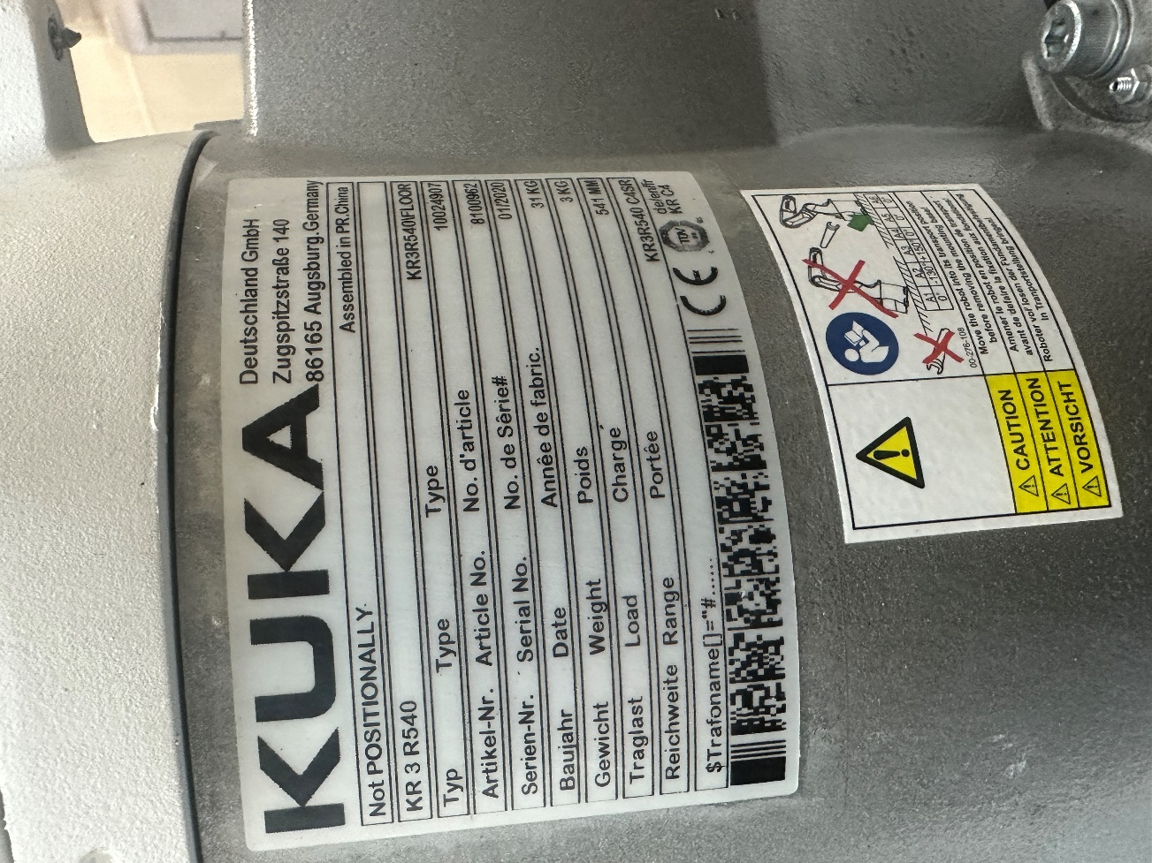

Adding KUKA Robot System with Gripper.

* KUKA Robot KR 3 R540
  + Type KR340FLOOR

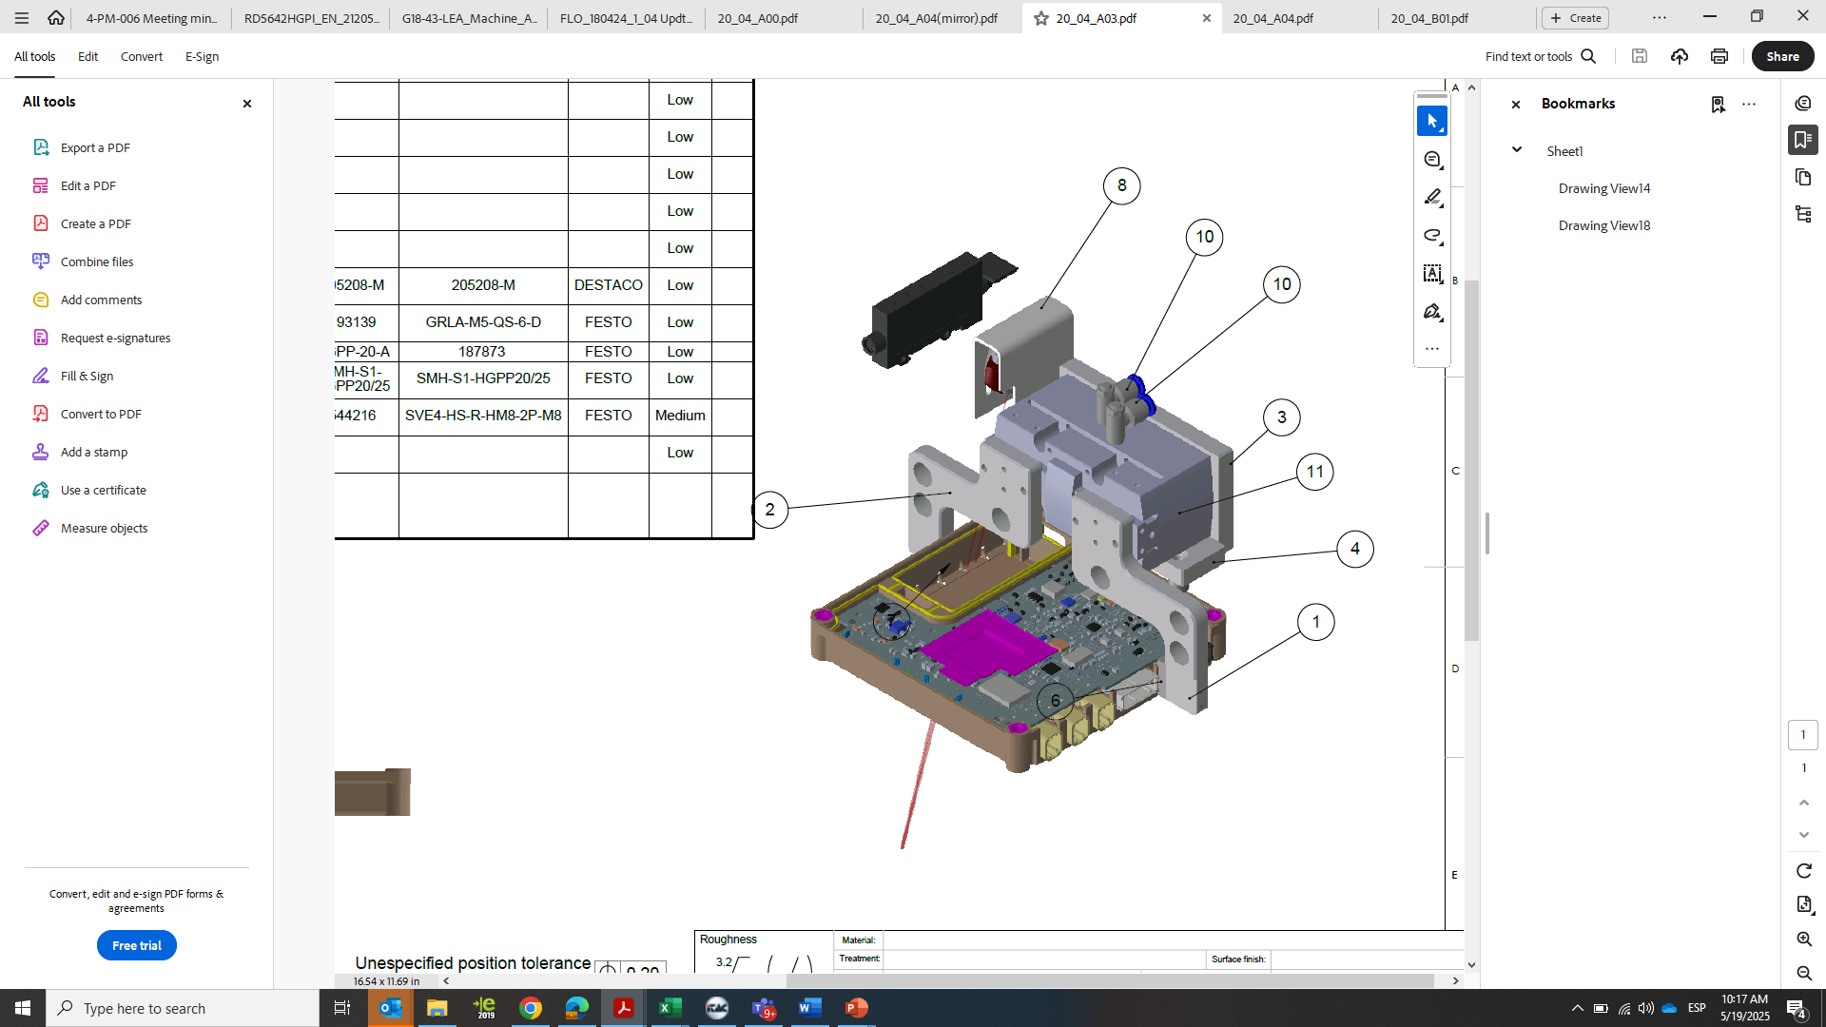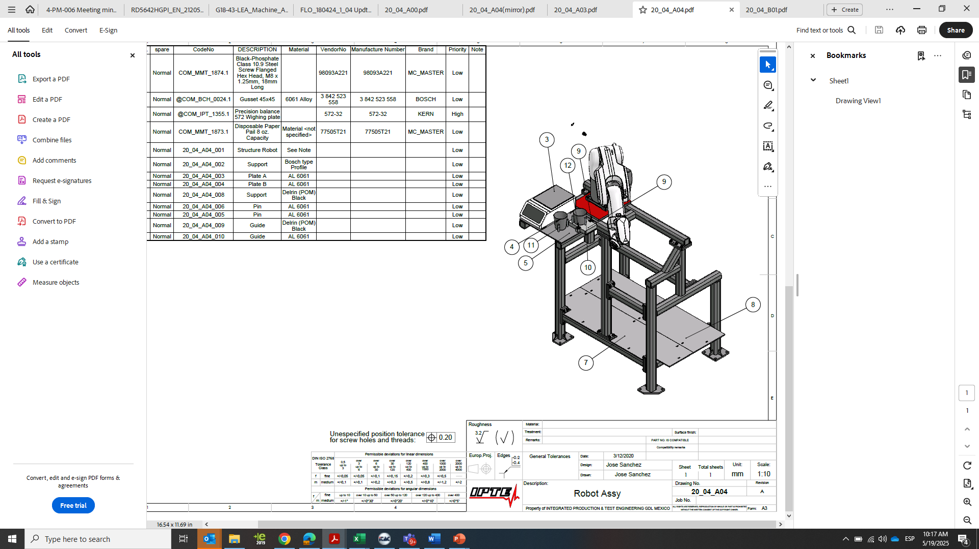

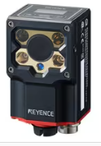 KUKA System and Scale Gap filler validation Gripper on KUKA system only for Conbox 2020 on conveyor transfer

Adding Keyence scanner SR-1000 for PCB QR for ITAC validation.

Adding Keyence Vision System for Gap Filler coverage validation.

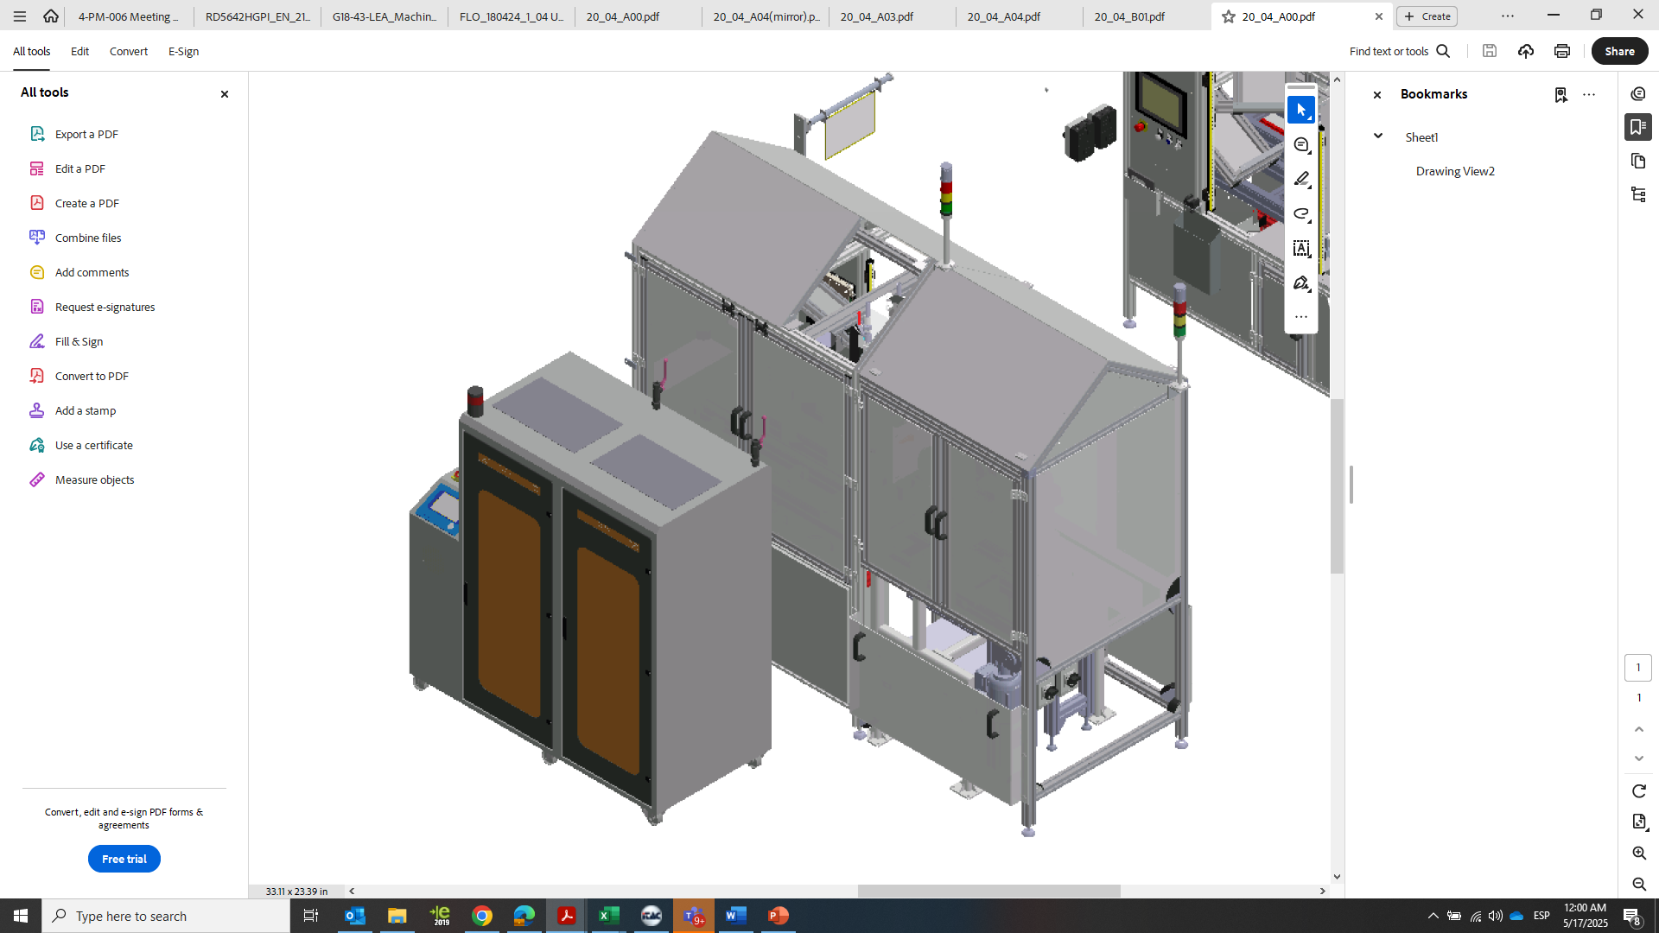

Scheungenpflug System for Bergquist Gap Filler TGF 2000 Part A & Part B

CBOX CURRENT LINE –

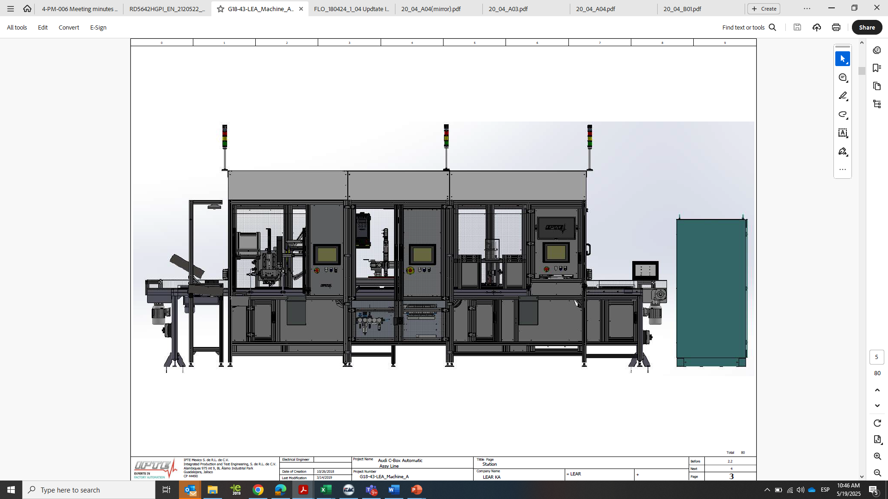

Press Station

CHANGES –

*Cycle time: 35 Seg*

Adding Upper tooling Interchangeable for Cover housing between C-box and Conbox

CBOX CURRENT LINE –

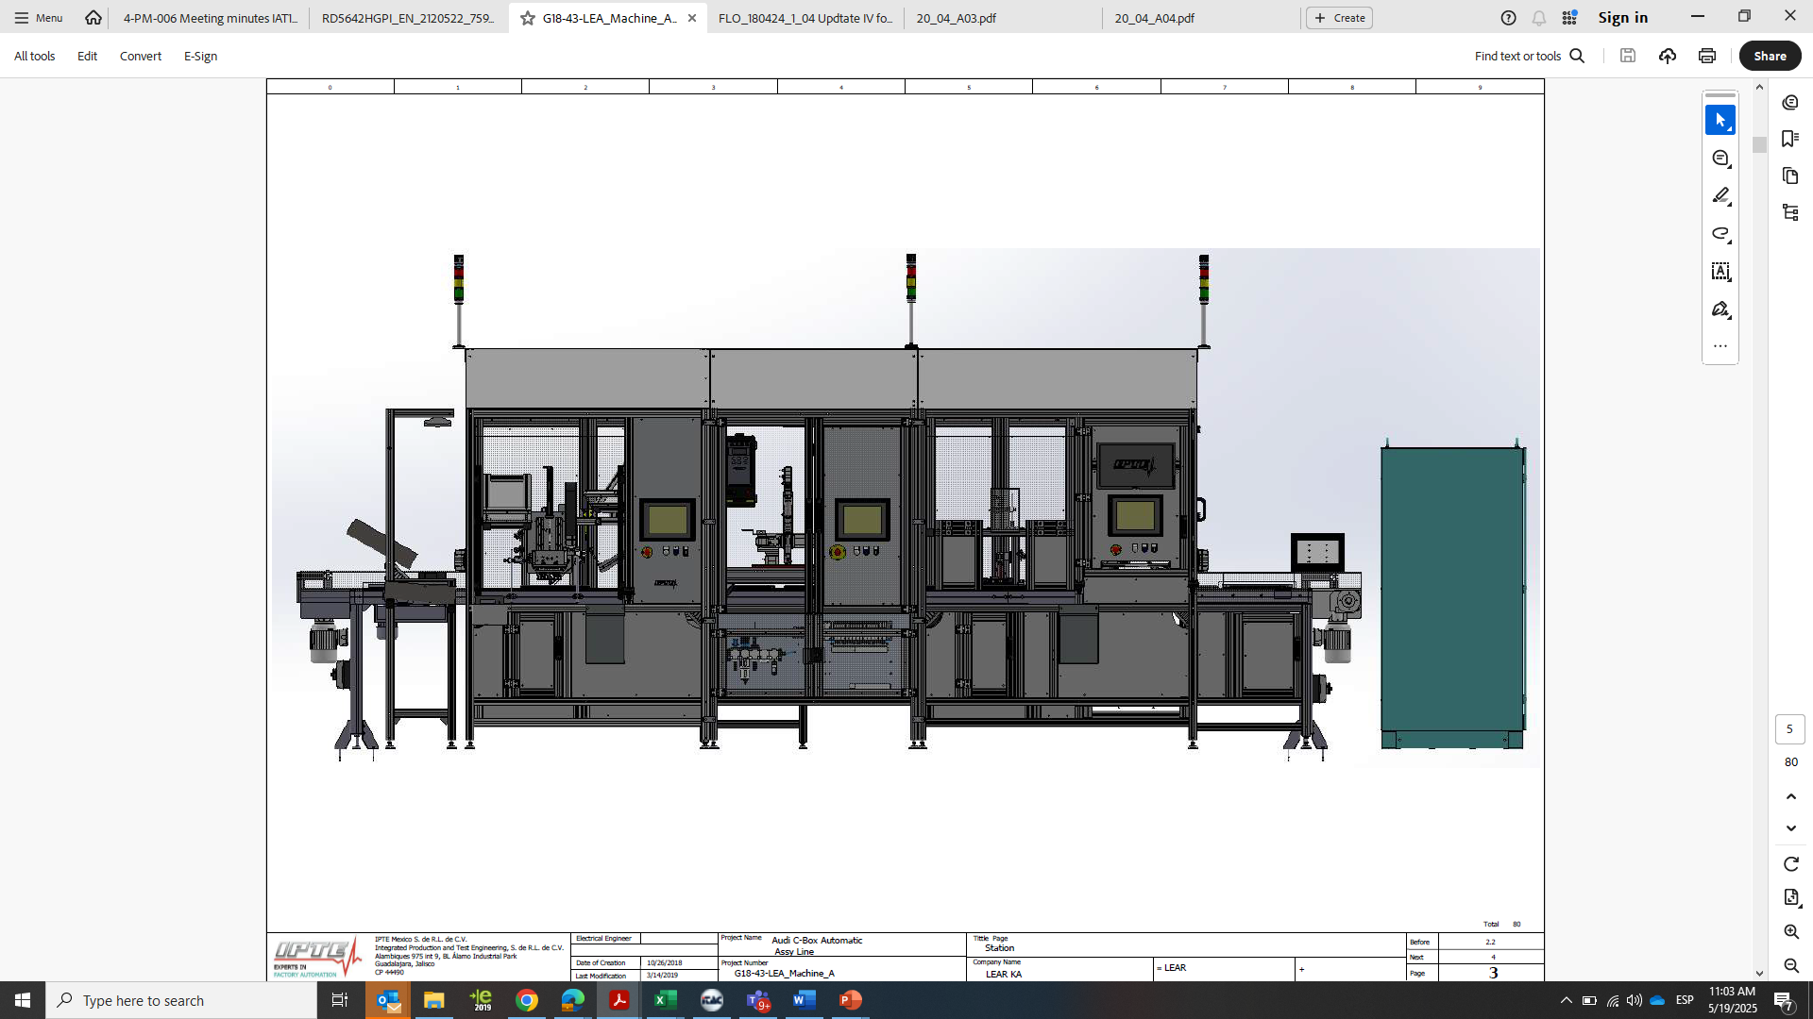

Screwdriving Station

CHANGES –

*Cycle Time: 35 Seg.*

Adding New cartesian gantry Robot (NOT Janome) and Screwdriver upgrade (PF8000), Atlas Copco screw bowl feeder

Use Atlas Copco toolnest system for traceability tightening control.

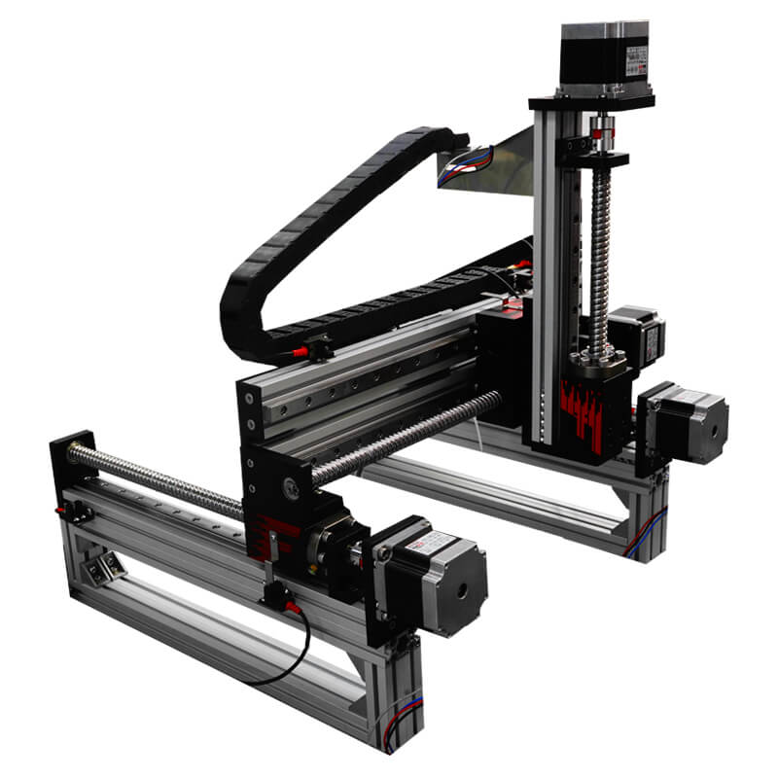

CBOX CURRENT LINE -

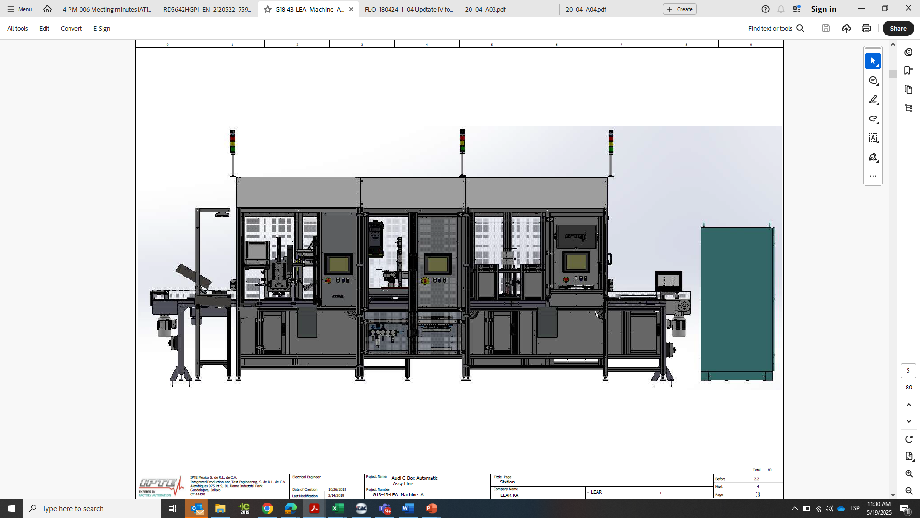

Battery assembly station

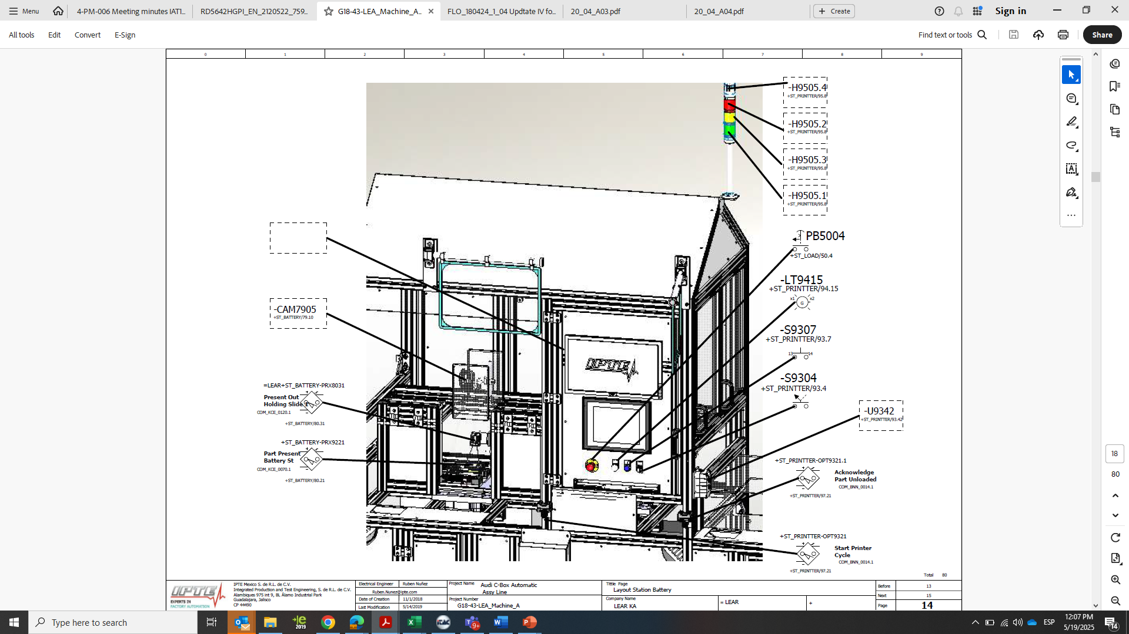 NOT CHANGES

*Cycle time: 35 Seg*

Adding Rack for raw material

Batteries charges

CBOX CURRENT LINE -

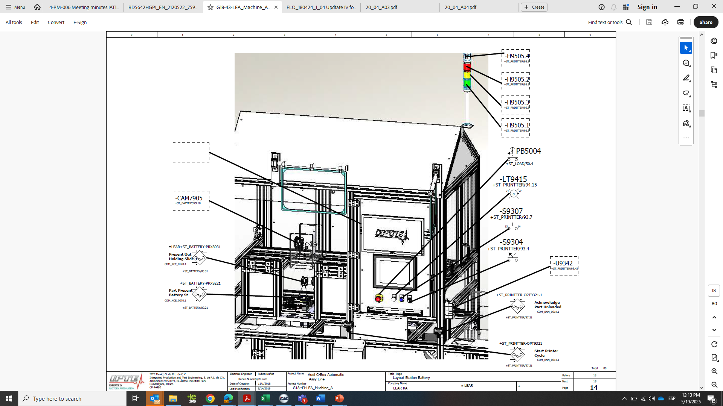

Printer station

CHANGES -

*Cycle time: 35 Seg.*

New gripper design for Conbox Housing

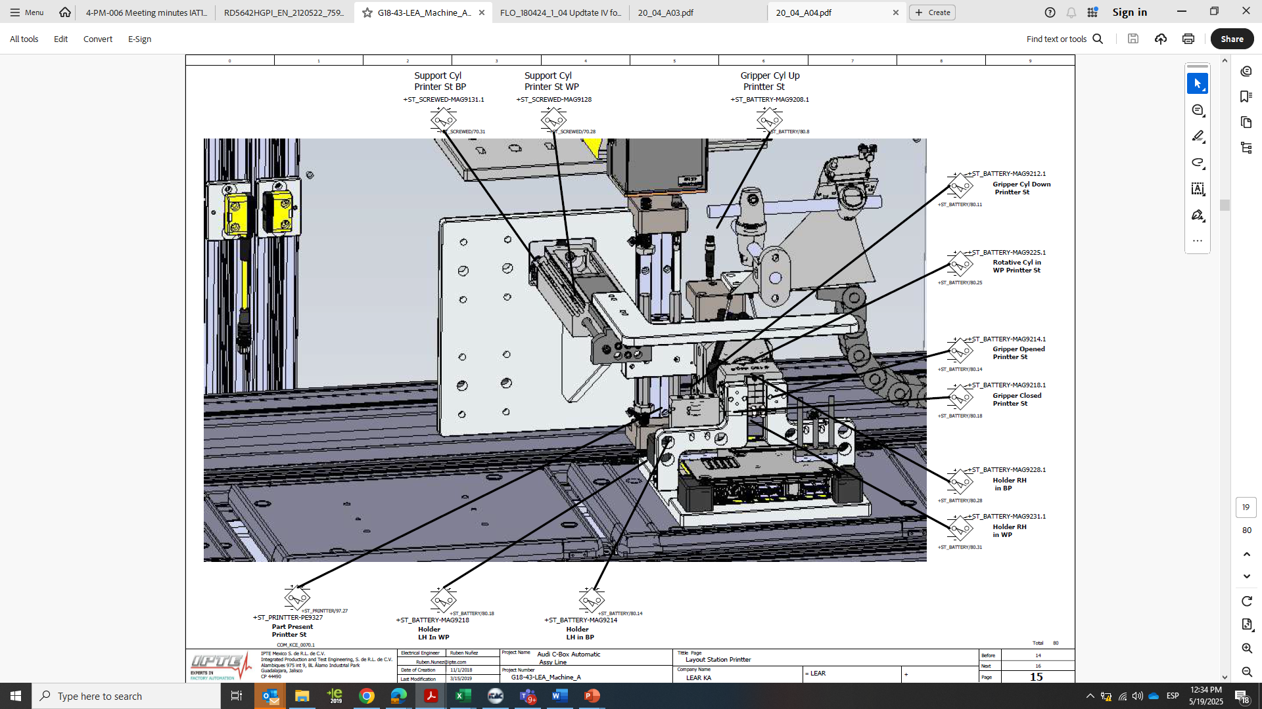

Gripper universal for Cbox & Conbox housing homologated.

Search new brand for printers (Zebra, Inkjet, Honeywell)

Not changed Label and configuration

PALLETS

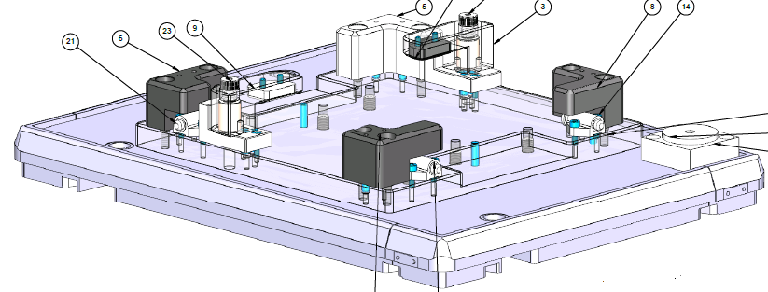

CHANGES –

Pallet Homologated and modified aluminum frame for Conbox Housing and Cbox housing.

Modify Qty 14 pallets Bosch.

PC -

CHANGES -

CPU to be consider as Lear Standards is Lenovo ThinkCentre M70q G 5, Ram 16 GB, HD 256 GB SSD.

CPU must contain Dual Ethernet Port. Port. 1 port Local Network and Port 2 Lear Network

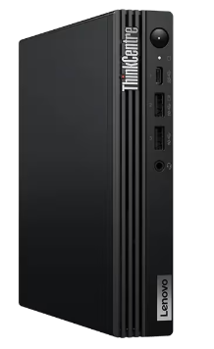

M70q G 5

Keyboard to be user is model Logitech Wireless Touch K400 Plus (please Include Batteries). Assure a special slot or support to contain the keyboard when the user is not using it.

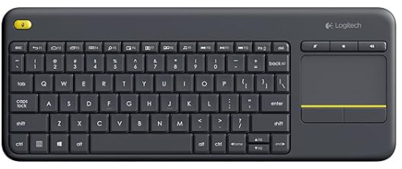

K400 Plus

**ITAC (Traceability System)**

Consider develop ITAC application and install it in this CPU to communicate PLC and Lear traceability system.

Is not allowed that the integrator do a connection for any device to PC with ITAC System like Scanners or Vision Sensor. This PC only is used to Communicate the traceability system and the PLC Machine

Bellow Data consider in the Recipe from Itac.

Lear Must Share ID Station to connect to Itac

Lear Must Share WO to validate traceability.

Supplier must assign the WO number when the User from Lear Change the WO in The Block System



**FINAL DOCUMENTATION**

* Electrical diagram
* Pneumatic diagram
* Mechanical drawings
* Machine user manual
* Plc and HMI program backups
* Peripheral backups
* Preventive maintenance routine
* Critical spare parts list